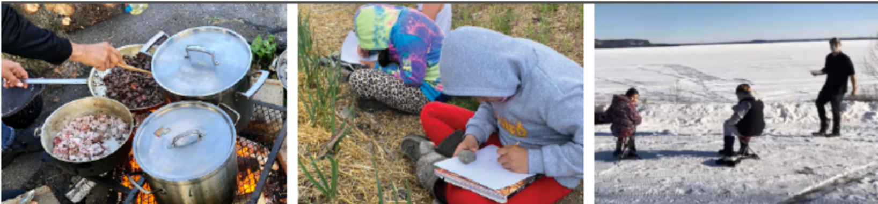

**Indigenous Foodways in Schools Grants**

**Share your interest - Grant Funds**

*For grants for the September 2025 - June 2027 school years*

*Important: This document is to help you think through your ideas to let us know you’re interested in an Indigenous Foodways in Schools Grant.

TO APPLY:

1. Thoroughly review the [About the Grants](https://www.farmtocafeteriacanada.ca/wp-content/uploads/About-Indigenous-Foodways-School-Grants-2025-EN-Final.pdf) document
2. Use the template below to draft your responses
3. Complete and submit your final application using the [online form](https://form-can.keela.co/ifis-application-en) (with the option to send information about your proposed program as one or more videos).

All applications must be received no later than

11:59 PM (PST) on March 28.

Questions or inquiries may be directed to [grants@farmtocafeteriacanada.ca](mailto:grants@farmtocafeteriacanada.ca).

**Section 1/3: Contact Information**

1. School Overview
   1. Name of school / organization to receive cheque (Full name please!)
   2. School / organization address

* Street address
* City/town
* Province/territory
* Postal code
* Country
  1. Mailing Address for receiving cheques (if different from above).
  2. Name(s) of school(s) that will be involved in this initiative (if not mentioned above).
  3. School type (check all that apply):
* Elementary
* Middle
* Secondary
  1. School type (check all that apply):
* Public
* Private
* Independent
* Other: specific details
  1. Does your school identify as any of the following? (check all that apply):

*Our school serves a high population of students who identify as:__*____

* First Nations
* Métis
* Inuit
* Other ethnically, culturally or racially diverse populations
* Newcomers
* Refugees
* Food insecure families
* Single parent households
  1. Where is your school located
* Rural community
* Remote community
* Urban / Suburban community
  1. Name of Indigenous community (if applicable)
  2. Approximately how many students are enrolled at your school?
  3. Grades taught
  4. Name of school district / board (if applicable)

1. **First Contact:**

* Name
* Title / Role / Relationship to the school
* Email address
* Phone number

1. Second Contact:

* Name
* Title / Role / Relationship to the school
* Email address
* Phone number

1. Third Contact (optional):

* Name
* Title / Role / Relationship to the school
* Email address
* Phone number

**Section 2/3: About Your Ask**

1. How much funding are you asking for?

*Enter a dollar amount up to $20,000*

**\*\*\* At this point in the form: You can either…**

**(a)** submit your answers to the following questions in the online form or

**(b)** create one or more videos to answer them. Please send video responses or questions about this process to [grants@farmtocafeteriacanada.ca](mailto:grants@farmtocafeteriacanada.ca).

1. Are you sharing your responses in writing below or will you be submitting them to us as videos?

* Responses are in writing below
* Responses will be sent to you in video format

1. Please tell us a bit about your school and your school community’s story (who, where)

*Please share information such as where you’re located, about your students, who in the community you’re connected to, your relationship with the community, what related activities your school has already been working on including whether your school and/or community have been working on food sovereignty initiatives, and any other information that you feel is relevant.*

1. What are you looking to do? (what)

*What are your vision, intention and/or goals for your initiative?*

*How will your school and community’s identity be honoured, respected and reflected in any programming offered and food served?*

* Has your school received funding from F2CC in the past?
  + - Yes/No
* If yes, when did you receive the grant?
* If yes, how will another grant help address any new or unique challenges your school is facing or opportunities you want to continue to address?

1. What’s your proposed timeline for your grant? (when)
2. Why is what you’re proposing important? What would be the impact on your students and your broader community? (why)

*This information is really helpful for us. As much as you can, please share details about why this grant would be important to your community and help us to be excited by what you’re proposing.*

1. Is there anything else you’d like to share with us?
2. (for applications for more than $3,000) If we feel that there is a good fit between this grant stream and your idea, and we reach out to ask you for more information, how would you prefer to share more about your idea? (Check all that apply)

* You share written responses to some questions we have
* You make and submit one or more videos in response to some questions we have
* Phone/zoom conversation (we’ll ask you whether you would be comfortable with us bringing an AI notetaker to this conversation)

**Section 3/3: Confirm Submission**

* I confirm that the grant submission is complete
* I confirm that the School Principal or Vice-Principal (or person with equivalent decision-making authority) has been engaged in the application development, and is supportive of this initiative.

1. Name of person completing the application
2. Email of person completing the application